Artificial Intelligence and Product Development

Dr. Mohammed R. Ahmed, Webster University, FL
Dr. Betty E. Ahmed, Liberty University, VA

ABSTRACT

Artificial Intelligence (AI) is not a new concept. It probably existed in the minds of researchers centuries ago, but researchers began experimenting with AI with the introduction of digital technology. Introducing the microprocessor brought digital computing power to individual researchers, learners, and professionals, leading to applications of the technology in business and management. We developed analog intelligent machines in the late sixties and seventies, and the aviation industry successfully applied autopilot in flight management. The growth in AI systems has resulted from technological changes, such as computing speed, capacity, capability, and storage. It has also created opportunities to build learning machines that will help managers make decisions and improve products and services in all functional business areas. The shortening of the average product cycle, intense competition in the marketplace, and rapid technological change has created an environment where the growth and profits of the firms depend on new product development. New product development has become a key element in developing a competitive strategy. Product development decisions involve significant investments and long-term value for the company. The products in the technology-based industries have become so complex that the companies have changed their production strategy from manufacturing to sub-assembling the products. New product development at the firm level requires research and development at the suppliers' level. The supplier has to become partners in the firm's growth strategy. The study aimed to investigate the process of new product development in the rapid growth industry, analyze the firm and supplier involvement in new product development, and develop a model for formulating a new product development strategy. The proposed model links the firm, supplier, artificial intelligence, growth, and business model for developing a long-term new product development strategy. The growth in AI learning capabilities and intense competition provide an excellent opportunity to investigate the new product development process and learning machine applications. The proposed 4Cs model would be helpful for the management of new product development and for creating a competitive advantage in the marketplace.

Keywords: Artificial Intelligence, Product Development, 4C’s of Product Development, Competitive Advantage,

INTRODUCTION

The purpose of the paper aims to share how artificial intelligence can be used in developing a new product or service. The concepts from artificial intelligence and new product development working papers are used to introduce the application of artificial intelligence in product or service development and to build a bridge between intelligent technology and product development strategy. The growth in technology alone will not help businesses solve customer problems unless it helps businesses develop improved solutions to customers' problems. Improved solutions and new product development satisfy the customers' wants and needs, generating revenue growth. This paper builds the bridge to understand the applications of AI in new products or service development. It will also include a discussion on artificial intelligence and 4C's new product or service development process and presents the applications of AI in the 4Cs process.

The word artificial refers to something created by humans to replicate close to real, but it is not natural. Intelligence is the ability to solve problems using logic, apply knowledge to enhance capabilities, the capacity to learn and apply knowledge to produce desired outcomes and other skills of the mind. Artificial Intelligence (AI) is a system created by humans using digital technology that includes hardware, software, and human contributions. It has unlimited business, education, and healthcare applications because it mimics Human Intelligence (HI). Humans can feel, observe, listen, analyze, and retain. The digital technology growth from data processing to text, image, voice, and video has created an opportunity to build digital systems that can create artificial systems that will help humans in research and development, business, and personal decision-making. It does not mean artificial intelligence will be more powerful than the human mind. It will have the capacity but is limited in capabilities because humans designed the systems to perform specific tasks. For example, a curious human mind may think of a new product or service to exploit the taxi segment of the transportation industry, solely thinking of future opportunities using the unused capacity of auto owners to create a competitive advantage in the transportation industry. In the case of AI, the system would have recommended a business model based on the data, knowledge, intelligence, and logic involved in the system for a business model to exploit the opportunities in the transportation industries. AI has limited capabilities but may pose unlimited capabilities based on the system's design. For example, you are meeting with ten experts in your field and are alone on one side of the table. Nine other experts are working together as a team. You will be overwhelmed by the team's responses because you face the human intelligence of nine people in the room. AI systems are digital systems and can store the billions of bits of data, information, knowledge, and intelligence of millions of people. It shouldn't be a concern because the stored information will help make good decisions in both business and professional life. As human beings and businesses, we are worried about the capacity of AI systems, but humans will still hold the edge over their capabilities because humans can learn, think, reason, use emotional energy, and solve problems.

ARTIFICIAL INTELLIGENCE IN BUSINESS

AI systems are designed to perform specific tasks by humans to enhance the capabilities of humans in business and management decision-making and performing tasks that are needed to achieve corporate goals. Businesses are aware of AI, but the cost of development and implementation is the obstacle to incorporating intelligent technology in business. The commercialization of processing, storage, and communication technologies has led to the growth of AI technologies. Technology helps companies generate growth, and because of business growth, new technologies are discovered to improve customer solutions to the problem. AI technologies are unique because of the learning component and have unlimited growth potential. Humans develop AI technology, which can be used to design new and robust systems. It is a circular function of growth. Human Intelligence creates AI that helps humans to develop new and powerful systems. AI and HI complement each other’s growth.

The growth in AI systems has resulted from technological evolution, such as computing speed, capacity, capability, and storage. All the systems, including AI, are designed based on the simple concept of input, process, and output. Intelligent systems are rule-based, and AI has learning capabilities that put them at the top of the hierarchy of intelligent systems. The following simple diagrams show design and progressive nature of systems.

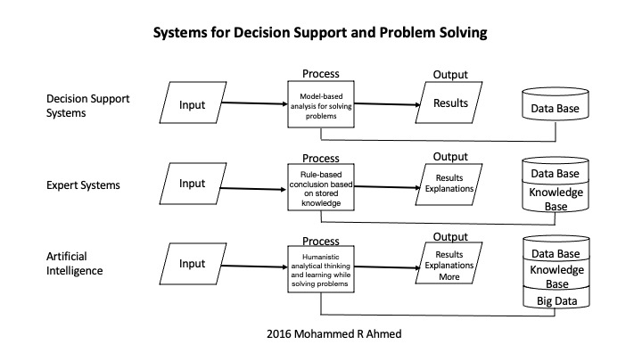
AI systems diagrams are more complex because of multiple inputs, and the processing includes hundreds and millions of algorithms and models, depending on the capacity of the system to solve problems and learning systems, and may involve several forms of output. The above chart shows the systems and simple processes involved in the system's approach to problem-solving or decision-making. We have used analog and digital intelligent systems for decades in the aviation industry and stock market trading. Autopilot and program trading is an excellent example of past systems used using real-time data. These systems helped managers in reducing risk and minimize human error in decision-making. We make decisions under risk and uncertainty in business, and the risk can be minimized by gathering data, information, and knowledge and gaining experience. AI is a valuable tool for business decisions, but managers should make decisions based on the risk and the cost and benefit analysis. Minimizing the risk in decision-making increases the chances of the survival and growth of a business. AI can improve decision-making and help managers in all functional business areas, such as management, marketing, finance, human resources, operations, and information system management. Decisions based on data, information, knowledge, experience, and logic help the business create a competitive advantage and shareholder value. In marketing, AI can be used for new product or service development. The rapid change in digital technology has changed the roles of researchers and managers worldwide. Although humans develop AI, Human Intelligence alone cannot create a competitive advantage in the marketplace. Businesses need AI to create a temporary monopoly on the knowledge to make decisions that will lead to a competitive advantage in the marketplace. Acquiring AI systems is not enough to succeed in the market. Managers must understand that they have to bridge the AI with the decision-making process so that AI is leveraged, and synergy is created in the decision-making process (Ahmed, 2023).

LEVERAGING AI TO CREATE A COMPETITIVE ADVANTAGE

In business, we use both financial and technological leverage to generate synergy. The leverage strategy aims to increase the returns and the firm's value. Financial leverage occurs when using debt to finance the firm's tangible and intangible assets. Financial leverage is created by combining debt and equity in a proportion that will minimize the average cost of capital, thus increasing the firm's profitability. The increase in profitability leads to a rise in the firm's cashflows and value. The firm's value depends on the cash flows and the firm's intrinsic value increases as the cash flows increase. Firms also invest in technology to create leverage by reducing the cost of operations and increasing profits and cash flow. The following simple diagrams show financial and technology leverage and its impact on the firm's value.

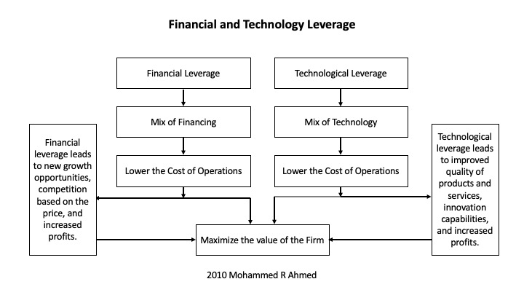

An optimal mix of financing lowers the average cost of capital. A lower cost of capital makes products that were less profitable before becoming attractive and creates new growth opportunities. It also allows the company to compete with a low-price strategy in the market. A proper selection and mix of technologies lower the firm's operations cost, improve the quality of products and services, and enhance the firm's innovation capabilities. It also reduces operating costs and increases profitability, allowing firms to reinvest profits in new technologies and other growth opportunities.There is a difference between financing alternatives and using alternative technologies to create leverage. For example, suppose the firm is generating 10% returns with assets of $1,000, and you invest $200 in new technology. In that case, the returns on investments should be more than 10% on $1,200 assets after adjusting for the cost of funds. We can use leveraging technology in all business functions, such as marketing, finance, human resources, operations, and information technology management, and create leverage by increasing revenues, reducing costs, and increasing the profits or intangible benefits, such as increased customer satisfaction.

Companies invest in processes, support, communication, and leveraging technologies. Process technologies are used in production and service operations, communication technologies are for internal and external customers and stakeholders, and support technologies are used for organizational support functions. These investments are critical and necessary for day to day operations of the business. Technology systems such as decision support, expert, and artificial intelligence are excellent examples of leveraging technologies. They reduce the cost of production or service and create a competitive advantage in the marketplace by helping managers in decision-making and supporting strategy formulation and implementation. Both financial and technology leverage allow firms to explore growth opportunities due to cost reduction.

This research focuses on the application of AI in the new product development process. AI systems allow managers to access billions of bits of information about the environment surrounding the firm and the competitors, which can be used for formulating a new product or service development strategy to create a competitive advantage. Technological leveraging also brings risks, including cost increase, technological obsolescence, competitors' access to the same technology, and employees' fear and trust in technology. Leaders are responsible in organizations for making employees aware that humans create AI. We should not be concerned about the growth of AI because it will generate growth in human intelligence Leverage is a strategy to increase returns by borrowing money and investing it in tangible or intangible assets. The key points leaders should remember when using technological leverage are the goal of the firm is to increase the returns on investment, reduce the risk, explore new growth opportunities, and minimize the cost. The point of leveraging technology is investing in technology that will increase the firm's value.

WHY NEW PRODUCT DEVELOPMENT IS CRITICAL FOR SUCCESS

Business growth is generated by expanding the company's product line, entering new markets, merging with another company, acquiring another company, forming alliances, or developing a new product. The new product line, new markets, mergers, acquisitions, and alliances are considered strategic decisions, and no specific model is available for making managerial decisions. These decisions are made at the corporate level and consider both the firm's internal and external environments. There are models available for new product development that involves functions such as marketing, research and development, engineering, and production operations (Cooper and Kleinschmidt, 1991). The problem with this approach is that the development process does not include continuous involvement of internal and external variables in product development. Also, the development process does not focus on the company's business model and strategic focus. The database search shows no current research on developing a model considering internal and external environments in the new product development process (NPD). The NPD usually involves a large amount of investment in research, development, and production operations. The failure of the new product in the marketplace will result in substantial investment losses to the firm, loss of market share, and a decline in the firm's value. The firm needs to adopt a new product development process based on the growth strategy to create a competitive advantage in the marketplace and increase the firm's value.

The firm's growth strategy differs from industry to industry based on growth characteristics. The industries are classified by their characteristics. The general classifications of the industries are negative growth, zero growth, emerging growth, constant growth, variable growth, and high growth. In the high-growth industry, the growth may be further classified as high variable growth and high-intensity growth. The high-intensity growth in the industry results from rapid changes in the environment and the marketplace. In the high-intensity growth industry, the speed of change is very high in both the industry's efforts to develop new products and the customers' efforts to adapt to new products. The high-intensity industry includes knowledge-based design, changing technologies, information (data, text, voice, image, and video) components integration, communication network integration, short product life cycle, intense competition, and product or service integration with other industries. The complexity of the products in the high-intensity industry requires the subassembly of products rather than manufacturing. New product development at the firm level involves research and development at the supplier's level. The firms in the high-intensity industry have to collaborate with the suppliers and make them partners in the firm's growth strategy because suppliers are part of the intensity in the industry. An industry may be classified as a high-growth industry. Still, it does not meet the intensity test because the growth does not result from the industry's innovation effort and the customer's willingness to adapt quickly to new products. The industry that includes data, text, voice, image, video, knowledge, and communication networks has a shorter product life cycle and is referred to as a high-intensity industry.

New Product or Service Development
The firm's survival depends on the growth in the marketplace. If there is no growth, the firm may go bankrupt. The growth is essential for the firm's survival in the market and for creating long-term value for the stockholders. Management is constantly looking for growth opportunities to fulfill the demands of the stockholders for a fair rate of return, maintain market share, and create a competitive advantage in the marketplace. The stockholders, the company's owners, are constantly looking for growth through an increase in stock price. The company's value (stock price) is determined in a financial market based on the firm's future cash flows. The future cash flows depend on the firm's ability to compete effectively in the marketplace and the competitive efforts to generate revenues greater than the cost. Competition in the product or service marketplace is like a battlefield (war zone). The shortening of the average product cycle, intense competition in the market, and rapid technological change has created an environment where the growth and profits of the firms depend on new product development. The firms constantly need to formulate growth strategies based on the overall growth of the industry and the ability to capture a portion of the competitor's market share by introducing new products. Industry growth is an opportunity for the company, and the cost of matching the industry growth strategy is usually lower than the cost of capturing the existing market share of the competitor. A growth strategy based on new product development involves a large amount of investment and significantly impacts the company's long-term value. The firm needs a model for new product or service development to minimize the risk of failure in the marketplace.

New Product Development
Growth is essential for the survival of the firm. It is also a challenge to most firms (Hamel and Getz, 2004), and in a dynamic industry, firms need to generate innovations while reducing development time and controlling costs (Kim and Mauborgne, 2004; Cooper and Edgett, 2005) to generate growth. Several studies (Cooper and Kleinschmidt, 1994; Kessler and Chakrabarti, 1999; Liker et al., 1999; Sethi et al., 2001; Troy et al., 2006) focused on NPD structure in the past, and still, there is no clear direction or a universal approach for successfully developing a new product. Cooper and Kleinschmidt (1991), Griffin (1997), Calantone and Di Benedetto (1988), and McDermott and O'Connor (2002) recommended a series of steps such as sequential tasks, stage-gate processes, or some systematic process to reduce risk and increase the success of the new product development. Millson & Wilemon (2002) and Shepherd & Ahmed (2000) suggested that the stage gate process will reduce time and increase the probability of success. Cooper & Kleinschmidt (1995) suggested that a structured process should be adopted in the new product development process and introduced flexibility by suggesting that stages can be skipped or combined to improve the success of the process. The structure process remained an integral part of the NPD process. Moorman & Miner (1998) suggested that improvisation can positively affect new product outcomes. The NPD process has no structured task, and the NPD team improvises the project as the project progresses. Most of the researchers in the past suggested the structured approach for successful product development. In recent years, researchers have introduced flexibility in the NPD process. The problem is the product development process differs from industry to industry, and the structure must be changed with the changing environment. The literature review shows that no specific model is available for developing a new product. The goal of this research was to review the existing literature and develop a model that meets the technological age requirements the provide NPD teams with a tool for successful development. The technology, economy, political, legal, and socio-culture elements of the environment are changing rapidly. The product's success in the marketplace depends on how fast the firm responds to the changing environment and develops solutions for the customer by introducing a new product. The proposed AI-assisted 4Cs model helps managers in the new product development process and minimizes the risk of failure.

The New Product Development Model
The proposed model suggests that NPD is a systematic process involving interaction between various organizational functions and considers environmental factors, suppliers, and the business model in developing a new product. This model is a break from the traditional thinking that it is the function by itself, and there is a beginning and end to the process. The proposed model suggests that NPD is a collaborative effort and a continuous process with feedback. The feedback is essential to learning how to improve the NPD process and succeed in the marketplace. This model will help the firm introduce new products designed to solve a customer problem, minimize cost overruns during the development process, and lessen the chances of termination of the new product. The models are helpful in product development because they guide the developers through steps to stay on the path to success. It doesn't mean models will always produce products that will be successful in the marketplace. All the models have an assumption and involve input from the user. The success depends on how well the assumptions fit the given market condition in which the product is introduced, and reliable data, information, and knowledge are incorporated into the product development process. AI is incorporated into the NPD model because it will minimize the risk by providing the knowledge and intelligence needed for product development. Although the human mind is more powerful than artificial intelligence, it still helps product development managers access the related information, analysis, and recommendations needed in the development process.

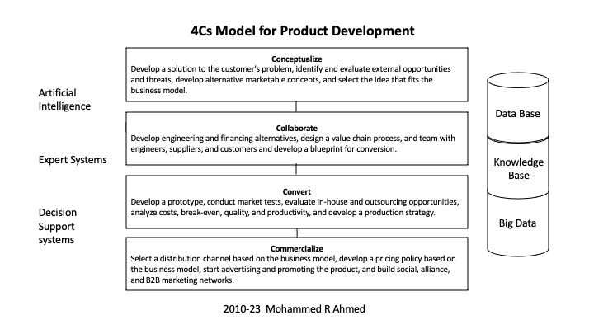

The proposed 4Cs NPD model includes four stages, and four steps are: 1) Conceptualize, 2) Collaborate, 3) Convert, and 4) Commercialize. The conceptualization stage begins with identifying the customer's problem, formulating solutions to the customer's problem, identifying several alternatives, and selecting the best solution for the customer. Choosing a solution doesn't mean it is a feasible solution. The solutions' feasibility is determined by the firm's internal capability to convert the concept into a product or service using the resources available or can be acquired. The firm needs to analyze the external environment, which includes technology, economy, political and legal, and social-culture variables, to identify the opportunities and threats to the proposed concept. Few marketable ideas are developed based on internal strengths and weaknesses and opportunities and threats from the environment. The marketable concepts are then analyzed to determine how they fit the business model.

Based on the best fit, a concept or two will be selected and enters the second stage, the collaboration. Suppose a firm is looking to develop a new service in the taxi segment of the transportation industry. The company developed a concept to bring users of the service and provider to a real-time platform for service and payment transactions. The company believes that the proposed idea will exploit the taxi industry and break the barrier to entry into the industry. The feasibility of the concept was evaluated by analyzing the internal environment, which shows that an app could be built to connect users and service providers. The ability to develop the app is not enough to convert the concept into a product or service. The firm has to evaluate the external environment to determine the economic, legal, technology opportunities and threats. For example, the opportunities are everyone has a cell phone, and it will link providers and users to a real-time platform for the payment transaction. The threat might be the legal licensing requirement and investment the service provider needs. The concept does not become a feasible solution to the customer problem until it fits the company's business model. The business model explains how revenues are generated, the costs and expenses are managed, and profits are generated. If the firm's business model proposes that revenues are generated by providing transportation to people who do not own cars, do not drive, do not like to drive, are away from home, or looking for alternatives for rentals. Cost and expenses are managed by using the unused capacity of auto owner operators and on-demand matching services, pricing, and payment management. The profits are generated by charging fixed portions of revenues for the real-time platform and services to conduct business. In this case, the proposed product and service concept fits with the firm's business model, and the firm enters the second stage, collaboration.

In the collaboration stage, the concept or concepts are analyzed by engineering and finance to identify the best available choice that can be engineered and financially feasible to produce and create wealth for the stockholder. A value chain process is drawn to collaborate design, engineering, finance, suppliers, and production operations of the organization. Suppose the firm developing a new service in the taxi industry identified the best available design for the real-time platform app that includes maps, service requests, price quotes, and customer payment transactions, and owner-operator account management. The firm needs the collaboration of credit card companies, financial institutions, owner-operators, cloud service, cell phone companies’ platforms, and web service providers to prepare the blueprint. The goal of the collaboration is to create value for both customers, owner-operators, and the firm at each node of the value chain. For example, value is created by improving the app’s ability to quickly access the maps and identify the location of customers and available cars for transportation service, payment service, and dispute resolution. The significant value in the value chain comes from the owner-operator, who uses the unused capacity of the automobile to provide transportation service. In the regular taxi service, there is capital investment for the vehicle compared to the owner-operator who has purchased the car for personal use and partly uses it for the transportation service. The collaborative efforts will result in a blueprint that will be used to convert the concept, design, and actions of the collaborators into a product.

In the convert stage, a prototype is developed using the blueprint and is tested in the laboratory for success in solving customers' problems. Also, a market test is conducted to determine how the customer perceives the proposed solutions to the problem. Based on the feedback, the firm will be able to make modifications to the new product and begin full-scale production. Next, the firm will decide whether to produce or outsource the production of the new product or service based on the available opportunities. At the same time, break-even, quality control, and productivity are conducted to formulate the best production strategy for the new product. Suppose a firm is looking to develop a new service in the taxi segment and develop an app for providing the service and test it by installing it on cell phones. The customers use the apps in real-time to utilize the service. The firm has to conduct a market test to determine whether improvements are needed before introducing it to the public on a full scale. They will select a single market and offer potential customers and owner-operators incentives to participate in the market test to determine glitches in the software, payment transaction, requesting service, communications issues, and quality of service. The firm will modify areas of concern using the feedback received during the market tests. The market tests will also provide the data to determine the break-even point for the company and cost structure analysis to control the cost based on the business model. Once the product plans are prepared, the next stage is the commercialization of the product.

In the commercialization stage, the firm will analyze all the available distribution channels and select the one best fitted to the business model. It will also ensure that the pricing policy is aligned with the business model and the cost-recovering strategy of the firm. The firm starts advertising and promotion and communicates with the customer the value of the product and its ability to solve the customer's problem. In addition to advertising and promotion, the firm will build social marketing, alliance, and complementary business marketing networks. Suppose a firm is looking to develop a new service in the taxi segment, and they have tested the platform and app used to connect the user with owner-operated transportation. The firm needs to attract owner-operators in the forward channel because they provide service and an app store where customers can download the apps. These two channels are critical for this business because it is needed to match customers with the on-demand transportation needs of the car owner-operators, locate and direct customers and service providers, pricing of service, and payment management. Service pricing is also critical to create a competitive advantage and provide value to the customer. At the same time, the firm needs to make sure car owner-operator are earning profits and the firm's fixed percentage of revenues is enough to achieve the corporate profitability goals. The business model, quality service, distribution channel, and pricing policy are a few elements in the commercialization step. The firm should develop a promotion strategy to ensure revenues are above the break-even and generating profits so that both car owner-operators and the firm are achieving profitability goals. Advertising, promotion, and alliance with other businesses to promote service are also needed to increase revenues. Social marketing is the most influential media in the digital age for businesses to promote their business.

Social media allows businesses and customers to connect twenty-four hours a day. Social media platforms enable companies to create virtual platforms, electronic communication, and share information with customers. Social media companies attract billions of people to their online platforms by making them free to access. The use of AI by social media companies to provide related customer and market information for business decisions has made them valuable business partners. AI use in social media has created profit opportunities for social media companies, and the companies have become helpful data providers for strategic decisions in business. Many social media companies have also introduced fee-based products and services for their business customers, and the information is critical for formulating the promotion strategy for the businesses. Social media is powerful because it gives companies access to customers, the ability to determine the wants and needs of customers, and potential new opportunities for growth. The media is powerful because of people's willingness to participate on the platform, share their views, and negotiate with businesses.The success of commercialization sometimes depends on the information needed for formulating the promotion strategy. The following diagram shows the participants in social media and data collection and using artificial intelligence to provide business intelligence for business decisions, including new product development.

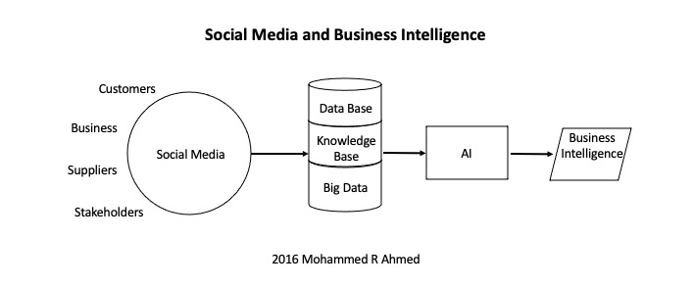

The growth in technology has created opportunities for businesses to collect and store data about customers, products, and services and led to the creation of big data. When you have access to billions of bits of data, information, knowledge, and intelligence, you need technology to help refine the data and provide helpful information or intelligence for business decisions. Managers can utilize three levels of technologies: decision support systems, expert systems, and artificial intelligence in new product development decisions. The application of AI in NPD will enhance the decision-making process because it is a collective intelligence of millions of people. It is a virtual collection of billions of bits of stored data, information, and knowledge from millions of people. Algorithms connect, extract, analyze, learn, and share the intelligence as a response in seconds with the users. It is an excellent tool for enhancing knowledge and making informed decisions in the new product development process because it reduces the time involved in the 4Cs of the product development process. AI and other corporate intelligent systems are needed to conceptualize, collaborate, convert, and commercialize steps because each involves decision-based on internal and external environments that need access to databases, knowledgebase, and big data. All four steps involve what-if analysis, knowledge-based systems, and require artificial intelligence. The 4Cs model needs AI and other intelligent systems to improve the new product or service decision-making process to reduce the risk of failure or increase the chances of success. The 4Cs model provides a systematic approach to the new product development process in a rapid-growth industry. It assumes that NPD is a multifunction activity, continuous, collaborative, and based on the company's business model.

CONCLUSIONS

New Product Development is a critical factor in the growth and survival of small, medium, large, domestic, and international firms. Management must understand that the NPD process is not a functional management such as a marketing decision but a multifunctional one. NPD is not merely incorporating new technologies and design and test marketing. It involves a model that can include the internal and external environment, value chain analysis, business model alignment, the firm's strategic focus, and participants from other industries to develop a product that will contribute to its growth. Incorporating AI in the model enhances the capability and reliability of the 4Cs model in successfully developing a new product and generating future growth. AI is designed to perform specific tasks, and the NPD model involves four step-by-step tasks. For example, in the conceptualization step, AI systems that will help understand the customer's problems and provide an external environment in which the product will be introduced will guide managers in developing an idea that could be turned into a blueprint. The selection of an AI system depends on your tasks in each step of product development. The product development model with AI systems will help management understand the potential success of the new product in the marketplace and its impact on the firm's cash flows. Also, it will allow management to minimize the investment risk exposure in the NPD process by providing information necessary to make management decisions, such as modification or termination of the new product during the development process. In this global technological environment, NPD sometimes involves integrating and assembling components from several suppliers from different industries. An AI-assisted model approach will help the management understand the product's potential growth based on the new product's life cycle.

RFERENCES

Ahmed, Mohammed R, Why are We Concerned About Artificial Intelligence (AI)? (2023). http://dx.doi.org/10.2139/ssrn.4426900, 1-5.
Ahmed, Mohammed R, Simplified Business Model (April 2, 2021). Ahmed, Mohammed R, simplified Business Model Compensating (April 2, 2021). International Journal of Business Administration, Vol. 12, No. 3, pp. 36-41, 2021.
Calantone, R.J. and Di Benedetto, C.A. (1988) An integrative model of the new product development process: an empirical validation. Journal of Product Innovation Management, 5, 3, 201–215.
Cooper, R.G. (1979) The dimensions of industrial new product success and failure. Journal of Marketing, 43, 3, 93–105.
Cooper, R.G. and Edgett, S.J. (2005) Lean, Rapid and Profitable New Product Development. Ancaster, Ontario, Canada: Product Development Institute.
Cooper, R.G., Edgett, S.J. and Kleinschmidt, E.J. (2002) Optimizing the stage-gate process: what best- practice companies do-I. Research Technology Management, 45, 5, 21–27.
Cooper, R.G. and Kleinschmidt, E.J. (1991) New product processes at leading industrial firms. Industrial Marketing Management, 20, 2, 137–147.
Cooper, R.G. and Kleinschmidt, E.J. (1994) Determinants of timeliness in product development. Journal of Product Innovation Management, 11, 5, 381–396.
Cooper, R.G. and Kleinschmidt, E.J. (1995) Bench- marking the firm’s critical success factors in new product development. Journal of Product Innovation Management, 12, 5, 374–391.
Cooper, R.G. and Kleinschmidt, E.J. (1987) New products: what Separates Winners from Losers? Journal of Product Innovation Management, 4, 3, 169–184.
Cooper, R.G. and Kleinschmidt, E.J. (1991) New product processes at leading industrial firms. Industrial Marketing Management, 20, 2, 137–147.
Griffin, A. (1997) The effect of project and process characteristics on product development cycle time. Journal of Marketing Research, 34, 1, 24–35.
Hamel, G. and Getz, G. (2004) Funding growth in an age of austerity. Harvard Business Review, 82, 7/8, 76–84.
Kessler, E.H. and Chakrabarti, A.K. (1999) Speeding up the pace of new product development. Journal of Product Innovation Management, 16, 3, 231–247.
Liker, J.K, Collins, P.D. and Hull, F.M. (1999) Flexibility and standardization: test of a contingency model of product design-manufacturing integration. Journal of Product Innovation Management, 16, 3, 248–267.
McDermott, C.M. and O’Connor, G.C. (2002) Managing radical innovation: an overview of emergent strategy issues. Journal of Product Innovation Management, 19, 6, 424–438.
Millson, M. R. & Wilemon, D. (2002). The Impact of Organizational Integration and Product Development Proficiency on Market Success. Industrial Marketing Management 3\, 1-23.
Mohr, J., Sengupta, S. and Slater, S. (2005) Marketing of High-Technology Products and Innovations (2nd edition). Englewood Cliffs, NJ: Prentice-Hall.
Moorman, C. & Miner, A. S. (1998). The Convergence of Planning and Execution: Improvisation in New Product Development. Journal of Marketing 62, 1-20.
Sethi, R. (2000) New product quality and product development teams. Journal of Marketing, 64, 2, 1–14.
Sethi, R., Smith, D.C. and Park, C.W. (2001) Cross- functional product development teams, creativity, and the innovativeness of new consumer products. Journal of Marketing Research, 38, 1, 73–85.
Shepherd, Charles & Ahmed, Pervaiz K. (2000). NPD Frameworks: A Holistic Examination. European Journal of Innovation Management 3, 100-106.
Sherman, J. D., Berkowitz, D., & Souder, W. E. (2005). New product development performance and the interaction of cross-functional integration and knowledge management. Journal of Product Innovation Management, 22(3), 399–411.
Souder, W. E., Buisson, D., & Garrett, T. (1997). Success through customer- driven new product development: A comparison of U.S. and New Zealand high technology firms. Journal of Product Innovation Management, 14(6), 459–472.
Troy, L.C., Szymanski, D.M. and Varadarajan, P.R. (2006) Generating new product ideas: an initial investigation of the role of market information and organizational characteristics. Journal of Academy of Marketing Science, 29, 1, 89–101.
Whitley, R., et al., 2003. The changing Japanese multinational: application, adaptation and learning in car manufacturing and financial services. Journal of management studies, 40 (3), 643–672.

